Lab 3: Comparator

Nico Whiteford

ECE 3720 – 007

9/29/17

*Abstract –* the purpose of this lab was to replicate the function of a comparator. In order to do this we had to construct a circuit that included a potentiometer connected to a microcontroller. The potentiometer is meant to control the LED outputs. This lab also allows us to practice writing to and reading from pins in the programming portion and to lean how to utilize the data sheet to set up analog pins and voltage reference. The final goal was to have 3 separate comparators turn on 3 LEDs sequentially with the single potentiometer.

*Procedures –* to start this lab I followed the crude block diagram shown in the figure below

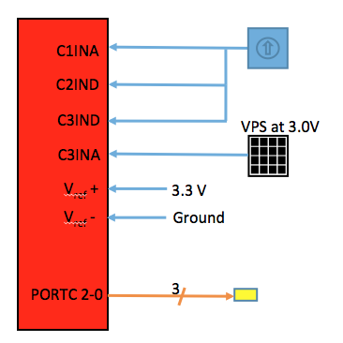

* Ground power the potentiometer and microcontroller
* 3 wires coming from pin 2 in the potentiometer entered C1INA, C2IND, and C3IND as found on the data sheet
* DIO in C3INA as shown on data sheet
* Vref+ plugs into pin 2 on the microcontroller to provide 3.3 volts and Vref- into ground
* 3 LED into pins 35, 36, and 37 which as 5V tolerant pins on the microcontroller
* Ensure all grounds are connected to each other
* Program the set up by following data sheet and write corresponding outputs to LED

*Results –* the proper result was to have LED 0 to turn on at roughly 1 volt LED 1 to turn on at roughly 1.7 volts and LED 2 to turn on at roughly 3 volts. At the end of the lab I was not able to modify the code to allow the circuit to have the desired output. After looking at the code after lab I made some modifications but was not able to test it with the circuit.

*Discussion –* The wiring of the code came easier than the first lab. Although the pre-lab schematic was not completed I was able to look at the figure provided in the power point to wire the NI ELVIS. Initially there was some confusion with where to connect the 3.3V since the NI ELVIS only sources 5 volts. After looking back at the power point I remembered that pin 2 provided the 2.2 volt source. Coding the circuit was tedious but straightforward since it just required following the table and circuit schematic provided in the data sheet on canvas. After wiring and coding of the circuit, my output resulted in no LEDs lighting up. After double and triple checking the wiring it could be determined that there was an issue with my code. The error was that I was writing the outputs to the wrong Pins in the while loop. After switching the LATBbits there were still issues with the LED outputs. When the potentiometer was off LED 0 was constantly on but when the potentiometer was turned all the way LED 0 turned off. This might have meant that the comparator was not comparing the correct values due to an issue in my code. After lab I took time to look at the code again and it turned out that the issue was not in the while loop but in the setup. The CVRONbits had not been set which means the comparator won’t even turn on. This was an amateur error, which resulted in not completing the lab in the given time.

*Conclusion –* In conclusion, this lab further increased my understanding with the microcontroller as well as reading-from and writing-to pins. I learned how to apply a potentiometer using digital IO and came close to getting desired results.

*Circuit schematic*

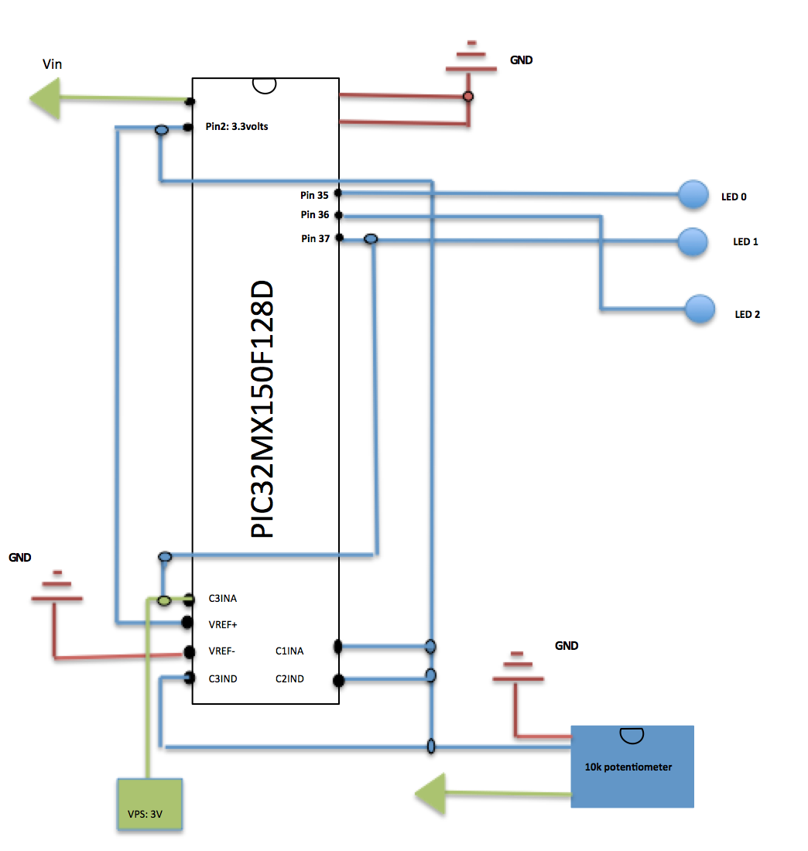

#include<plib.h>

void main(void){

TRISBbits.TRISB15 = 1;

CVRONbits.ON = 1;

CVRONbits.CVR = 15;

CVRONbits.CVRR = 0;

CVRONbits.CVRSS = 1;

//C1INA pin 23

CM1CONbits.ON = 1;

CM1CONbits.CPOL = 0;

CM1CONbits.CREF = 0;

CM1CONbits.CCH0 = 1;

CM1CONbits.CCH1 = 1;

//C2IND pin 22

CM2CONbits.ON = 1;

CM2CONbits.CPOL = 1;

CM2CONbits.CREF = 1;

CM2CONbits.CCH0 = 0;

CM2CONbits.CCH1 = 1;

//C3IND pin 20

CM3CONbits.ON = 1;

CM3CONbits.CPOL = 1;

CM3CONbits.CREF = 0;

CM3CONbits.CCH0 = 0;

CM3CONbits.CCH1 = 1;

//LED pins

//LED 0

TRISBbits.TRISB7 = 0;

//LED 1

TRISBbits.TRISB6 = 0;

//LED 2

TRISBbits.TRISB5 = 0;

while(1){

LATBbits.LATB5 = CMSTATbits.C1OUT; //pin 35 to LED 0

LATBbits.LATB7 = CMSTATbits.C2OUT; //pin 37 to LED 1

LATBbits.LATB6 = CMSTATbits.C3OUT; //pin 36 to LED 2

}

}